Herramienta de partes vinculadas alta dirección
Cambios mayo 2026

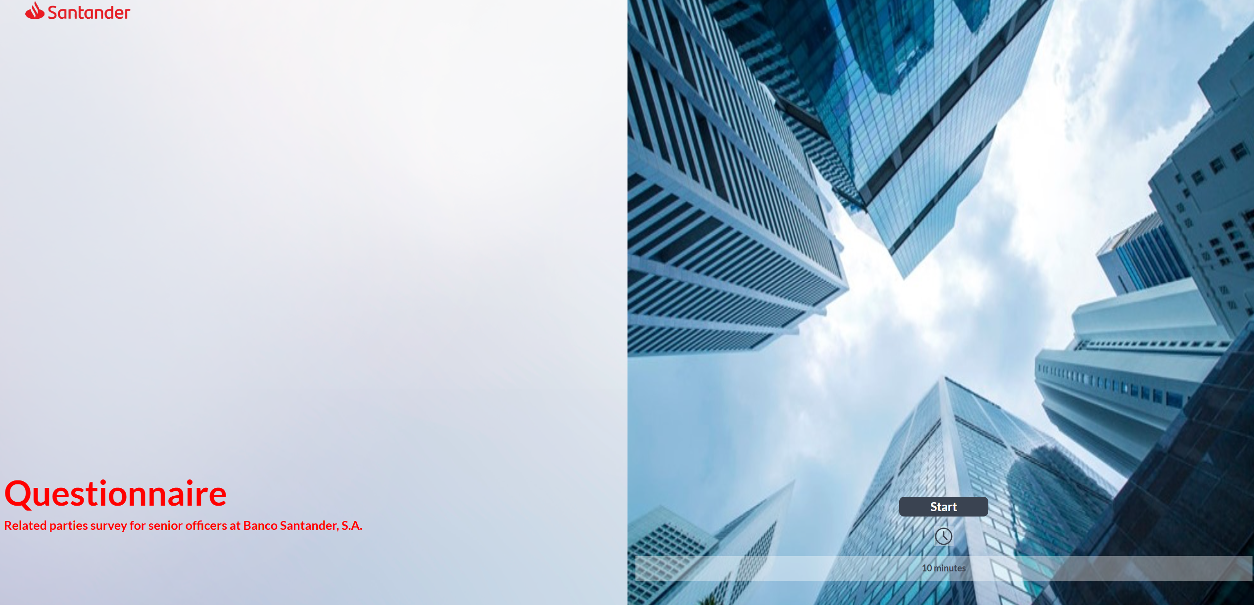
Portada:
- Cambiar la foto para evitar confusión con la reevaluación annual (la misma que para consejeros)
- Cambiar el texto de la portada por “Related parties questionnaire for Banco Santander S.A. senior management”
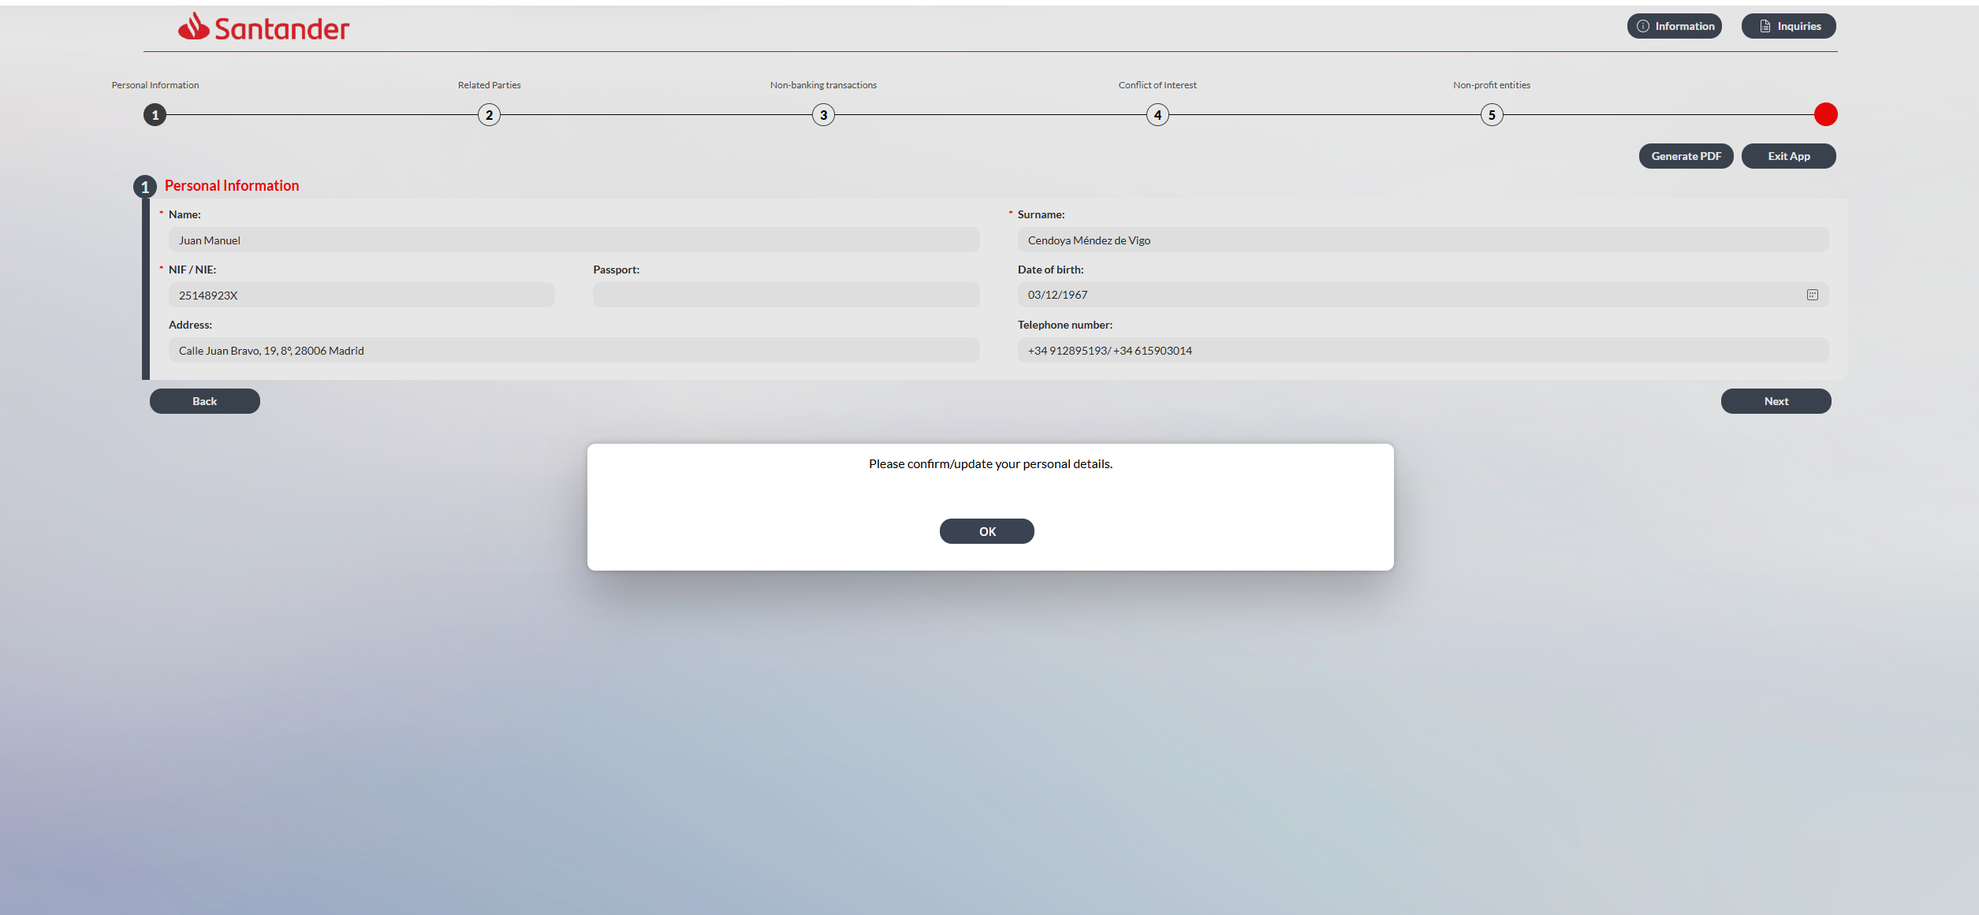
Ventana emergente:
Cambiar el texto de la ventana emergente por “Please confirm or update your personal information, as appropriate”.
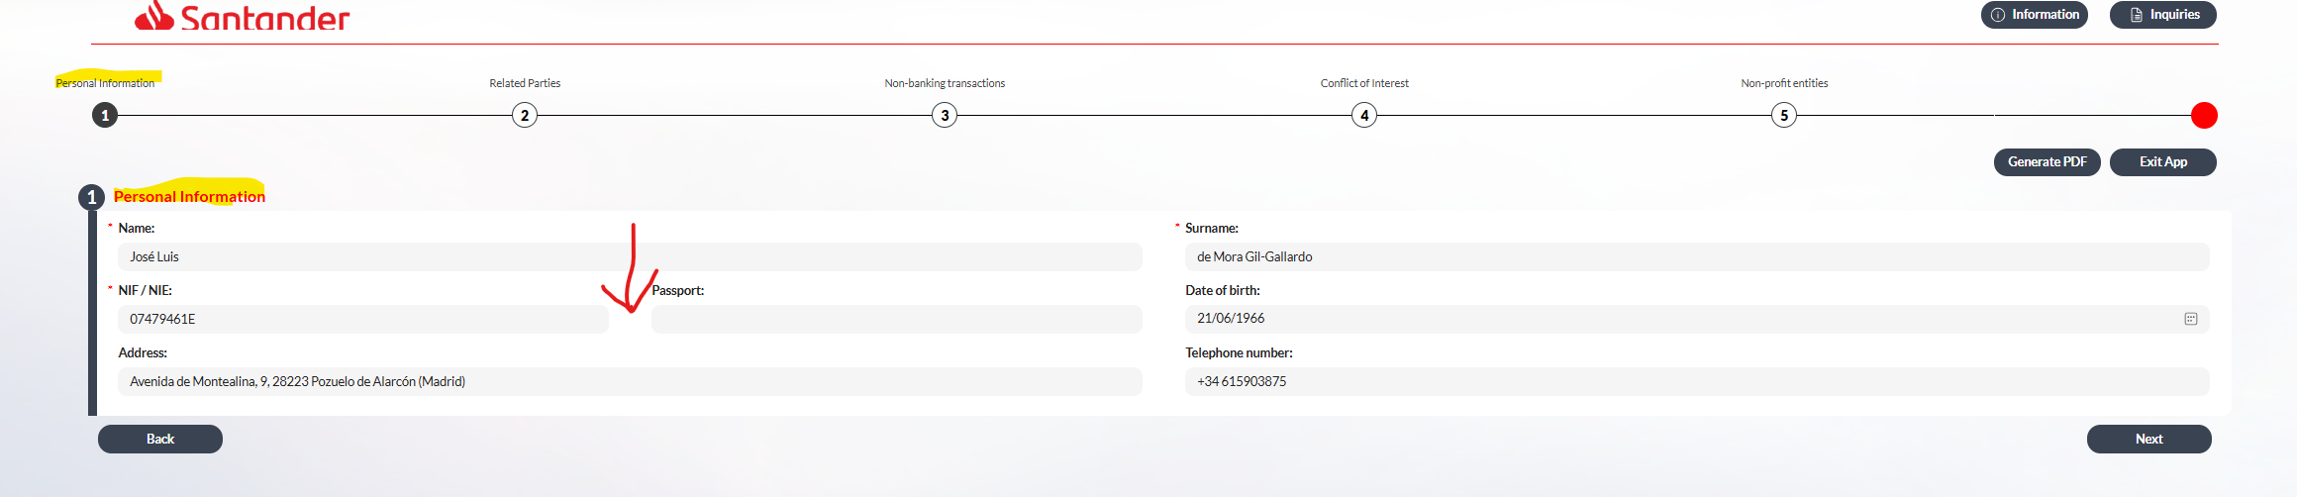
Pantalla 1:
- Sustituir “Personal information” por “Senior manager’s personal information”.
- En esta pantalla inicial sustituir “NIF/NIE” por “Spanish ID number (NIF for Spanish Senior managers/ NIE for non-Spanish Senior managers)”.
- Entre ese campo y el de “Passport”, donde marco con una flecha roja, incluir un nuevo campo para el número de identificación del país de residencia, que se titule “National ID number (non-Spanish Senior managers only) (in case of US Senior managers, please include US SSN)”.

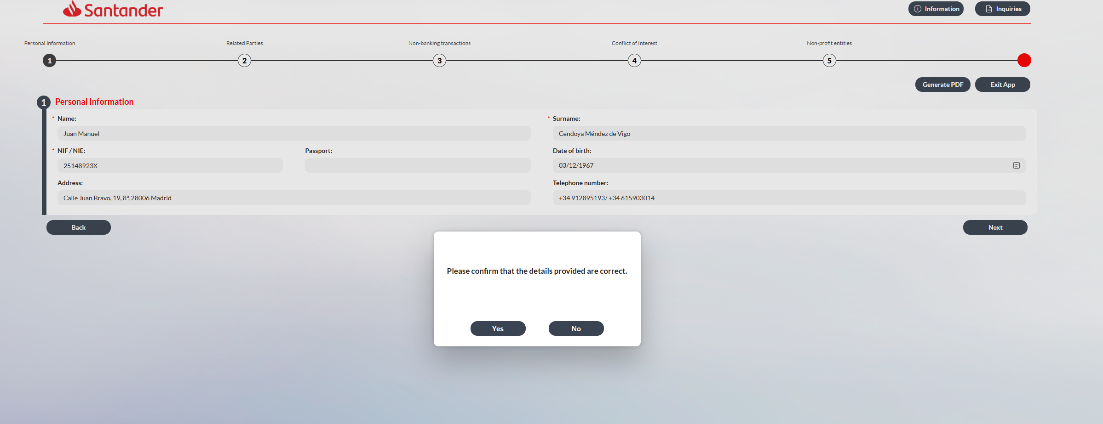
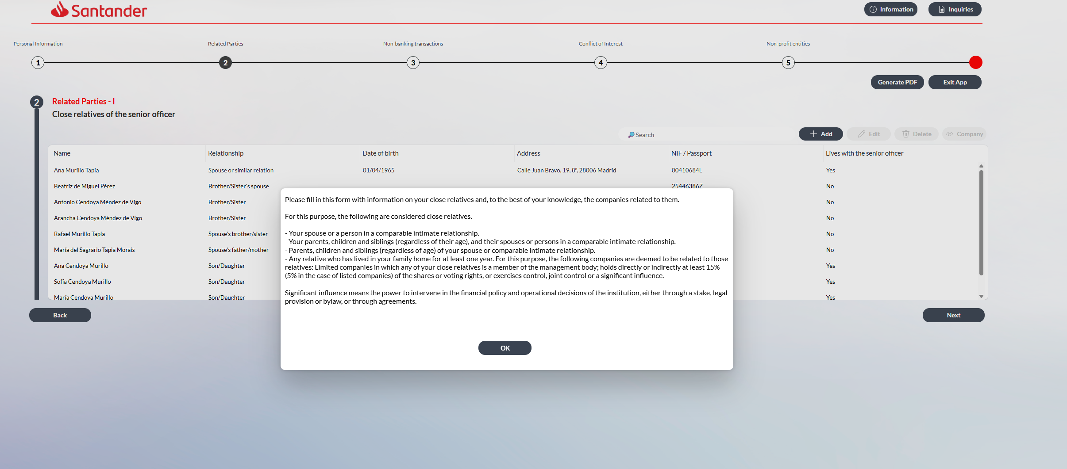
Ventana emergente:
- Sustituir el texto por este:
“Please fill in, to the best of your knowledge, the information on your close relatives and the entities related to them. For these purposes:
- The following are considered close relatives:
- your spouse or a person in a comparable intimate relationship (hereinafter “equivalent”);
- your children, parents and siblings;
- the children, parents and siblings of your spouse or equivalent ;
- the spouses or persons in a comparable intimate relationship of all the individuals listed above;
- your grandchildren;
- persons dependent on you, or dependent on your spouse or equivalent;
- any other relative who you may influence, or who may influence you, in their/your relationship with the entity; and
- any other relative with whom you have lived for at least the past year.”

- The following entities are deemed to be related to those relatives:
Companies
in which any of your close relatives:
- is a director or holds another managerial position;
- holds directly or indirectly at least 10% (5% in the case of listed companies) of the shares or voting rights; or
- exercises control, joint control or a significant influence (meaning the power to intervene in the financial policy and operational decisions of the institution, either through a stake, legal provision or bylaw, or through agreements).

- The following terms shall have the meanings set out below:
- Listed company means a company whose shares are publicly traded on a stock exchange.
- Asset-holding company means a company whose activity is limited to the holding of assets and does not carry out any economic activity.
- Other companies means any commercial company other than a listed company or an asset-holding company.

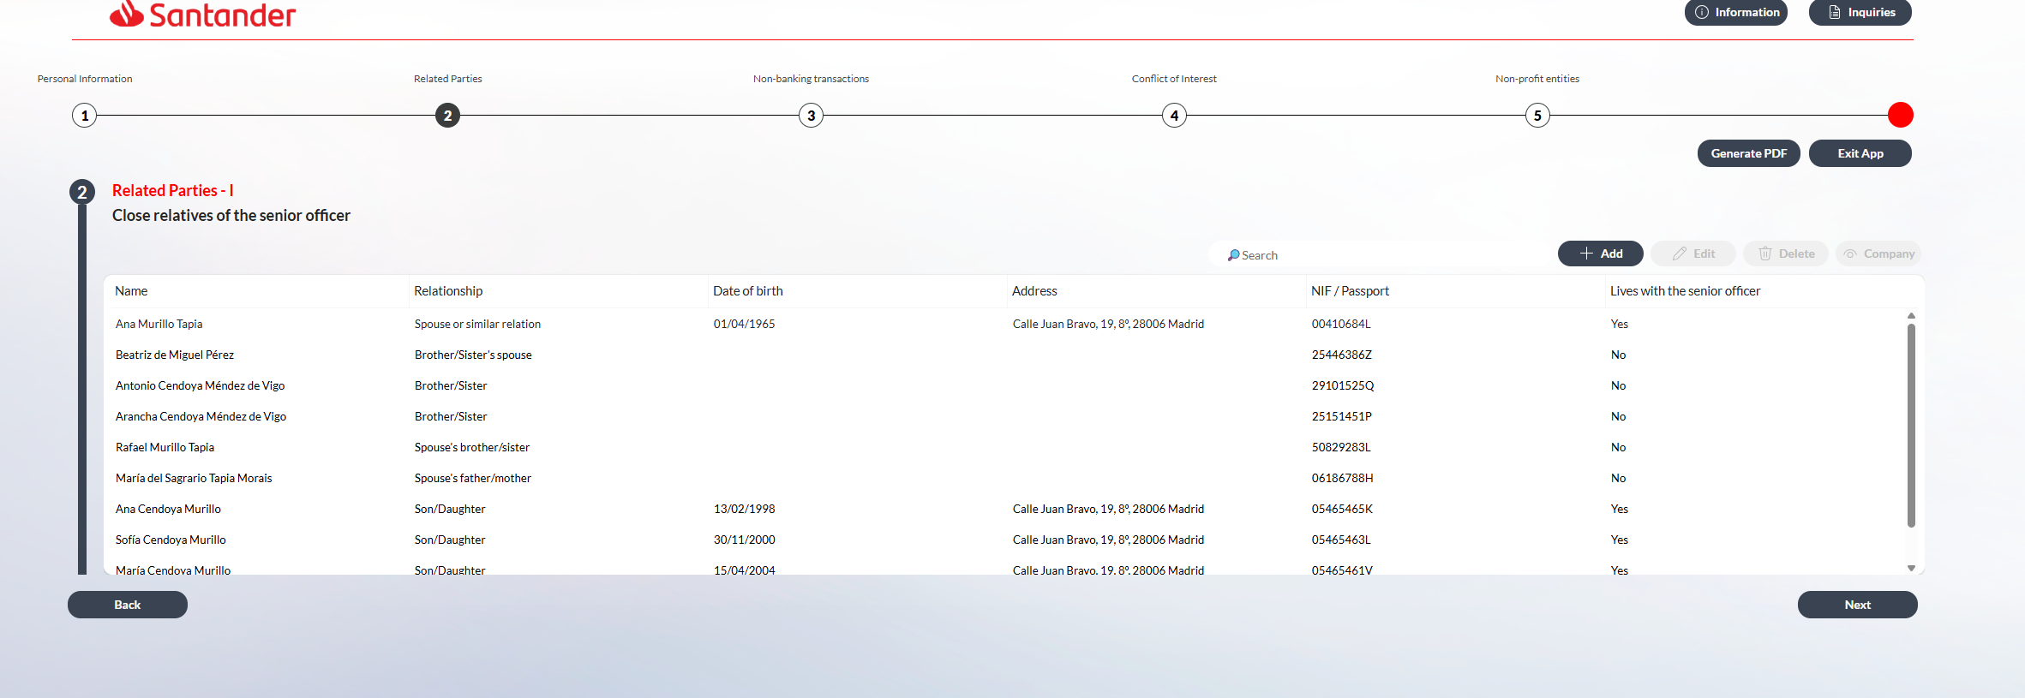
Pantalla:
- Cambiar referencia a “senior officer” por “senior manager”
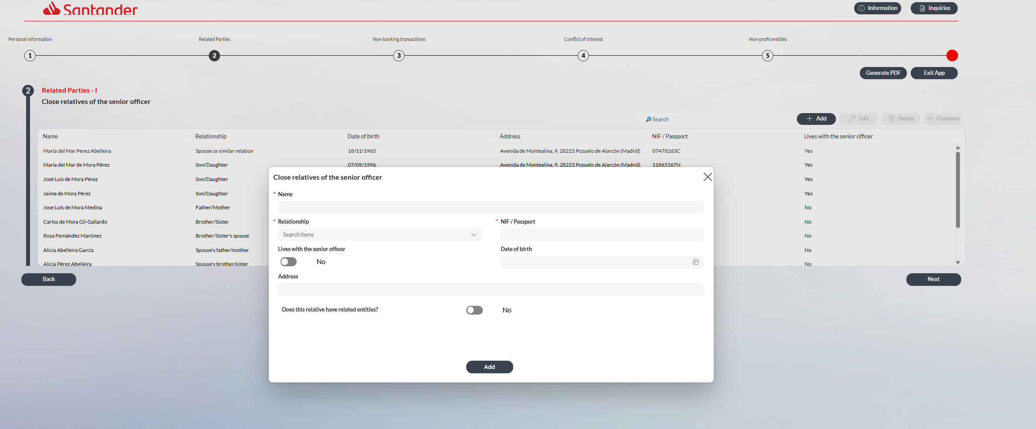
- Sustituir en el desplegable el texto “Spouse or similar relation” por “Spouse or equivalent”.

- Actualizar el desplegable de familiares para incluir nuevas categorías:
  - Spouse’s child’s spouse
  - Spouse’s parent’s spouse
  - Spouse’s sibling’s spouse
  - Dependant

- Añadir después de “NIF / Passport” otro campo que sea “National ID number (non-Spanish senior managers only) (in case of US senior managers, please include US SSN)”.

- Actualizar desplegable de position: el texto Senior manager por Managerial position

- Actualizar el desplegable de Type of company para actualizar el nombre de las siguientes categorías:
  - Cambiar “Commercial” por “Other companies”.
  - Cambiar “Listed” por “Listed company”.
  - Cambiar “Holding” por “Asset-holding company”.

- Actualizar el texto de los desplegables de shareholding:
- sustituir “Exercise significant influence” por “Control, joint control or significant influence
- ”.

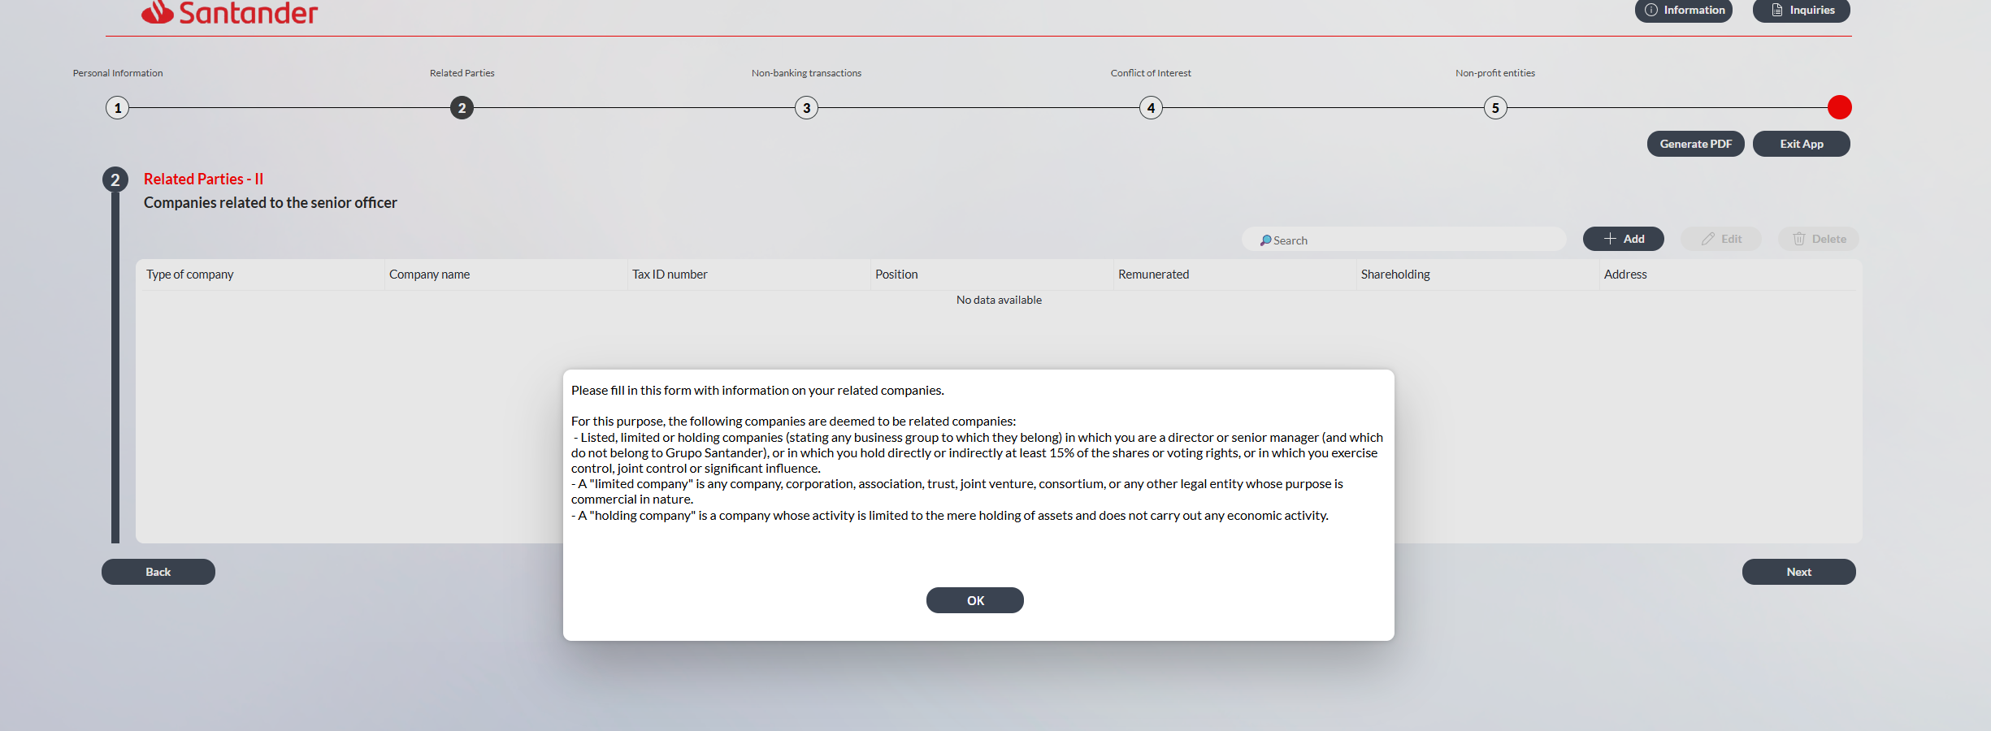
Ventana emergente
“Please fill in the information on your related entities. For these purposes:
- The following entities are deemed to be related to you:
Companies
in which you:
- are a director or hold another managerial position;
- hold directly or indirectly at least 15% of the shares or voting rights; or
- exercise control, joint control or a significant influence (meaning the power to intervene in the financial policy and operational decisions of the institution, either through a stake, legal provision or bylaw, or through agreements).

- The following terms shall have the meanings set out below:
- Listed company means a company whose shares are publicly traded on a stock exchange.
- Asset-holding company means a company whose activity is limited to the holding of assets and does not carry out any economic activity.
- Other companies means any commercial company other than a listed company or an asset-holding company.

Pantalla
- Cambiar referencia a “senior officer” por “senior manager”
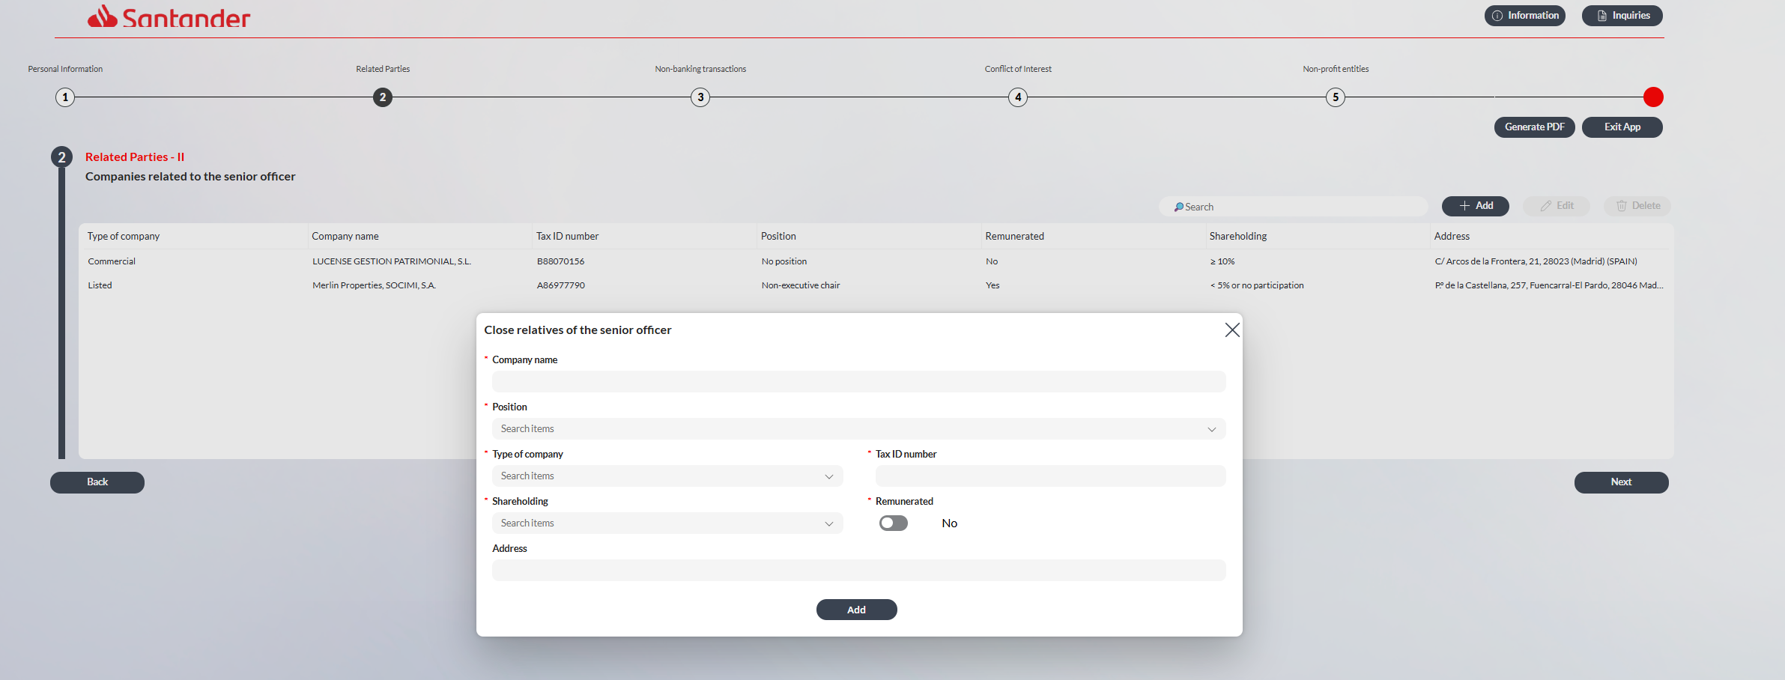
- Actualizar desplegable de position: el texto Senior manager por Managerial position.

- Actualizar el desplegable de Type of company para actualizar el nombre de las siguientes categorías:
  - Cambiar “Commercial” por “Other companies”.
  - Cambiar “Listed” por “Listed company”.
  - Cambiar “Holding” por “Asset-holding company”.

- Actualizar el texto de los desplegables de shareholding:
  - Sustituir “Exercise significant influence” por “Control, joint control or significant influence”.

  - Cuando se seleccione Listed company en el desplegable de shareholding cambiar el 5% por un 15%.

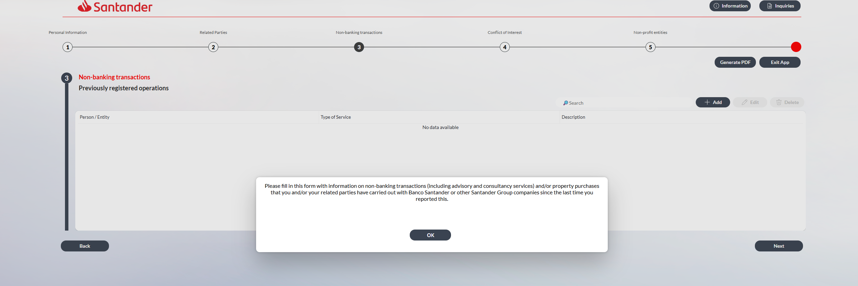
Ventana emergente
Cambiar texto por “Please fill in/update the information on non-banking transactions (including advisory and consultancy services) and/or property purchases that you and/or your related parties have carried out with Banco Santander or other Santander Group companies”.
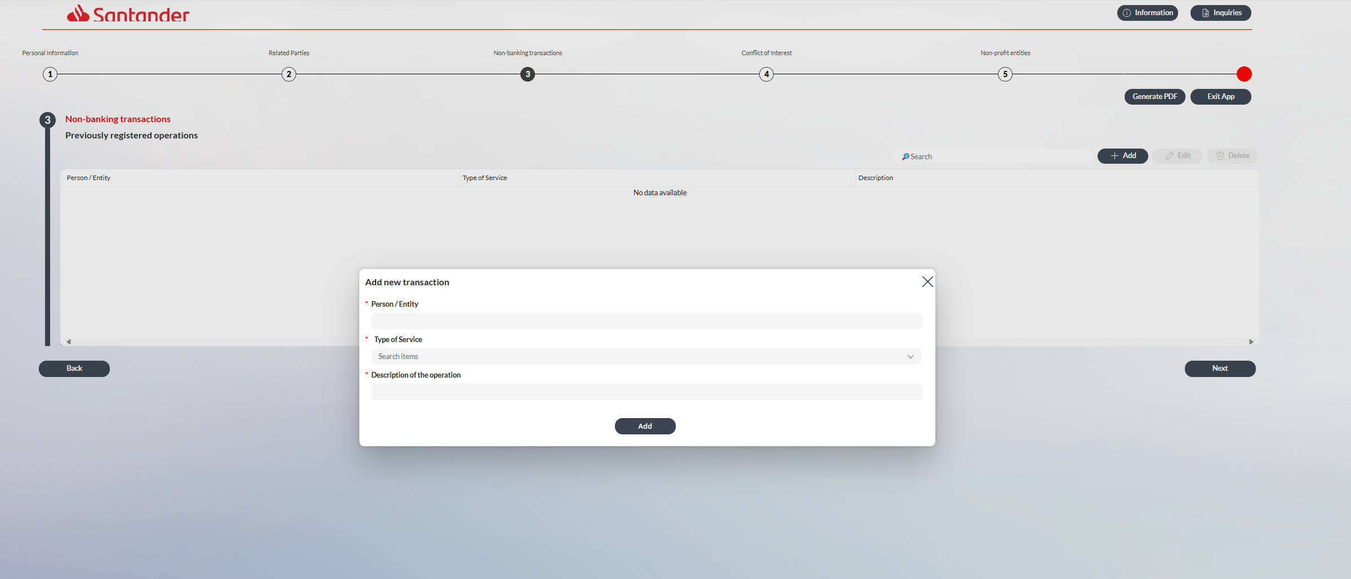

Desplegables “Type of Service” (poner “service” en minúscula):
- Eliminar “Leasing”.
- Cambiar “Counseling / Consulting” por “Consulting services”.
- Cambiar “Provision of services” por “Other services”.
- Cambiar “Others” por “Other transactions”.
- Cambiar “Description of the operation” por “Description of the transaction”.
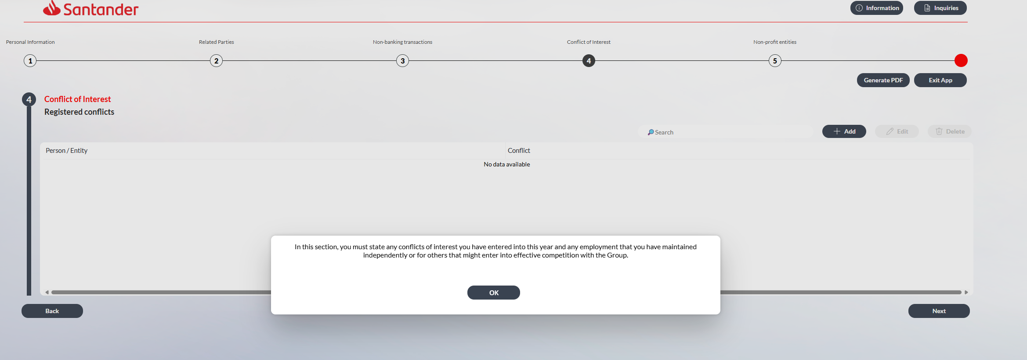

Elimiar el apartado de conflicts interest

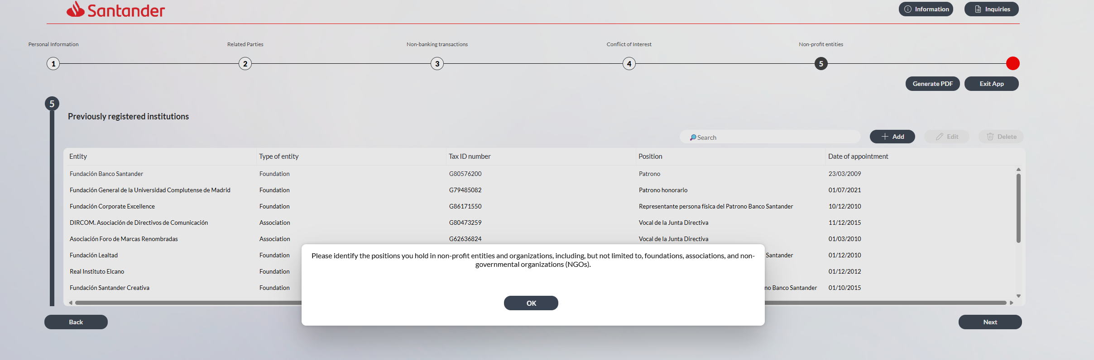
Ventana emergente:
Cambiar el texto por: “Please provide details of any positions you hold in non-profit entities or organizations, including, but not limited to, foundations, associations, and non-governmental organizations (NGOs).”
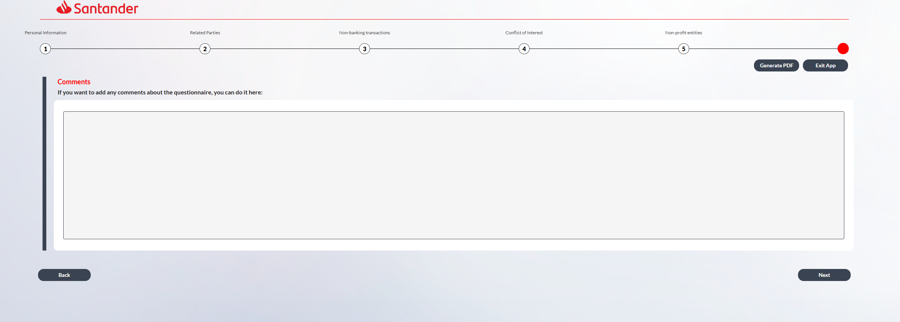
Pantalla:
Cambiar el texto por: “If you wish to add any comments regarding the questionnaire, you may do so here:”
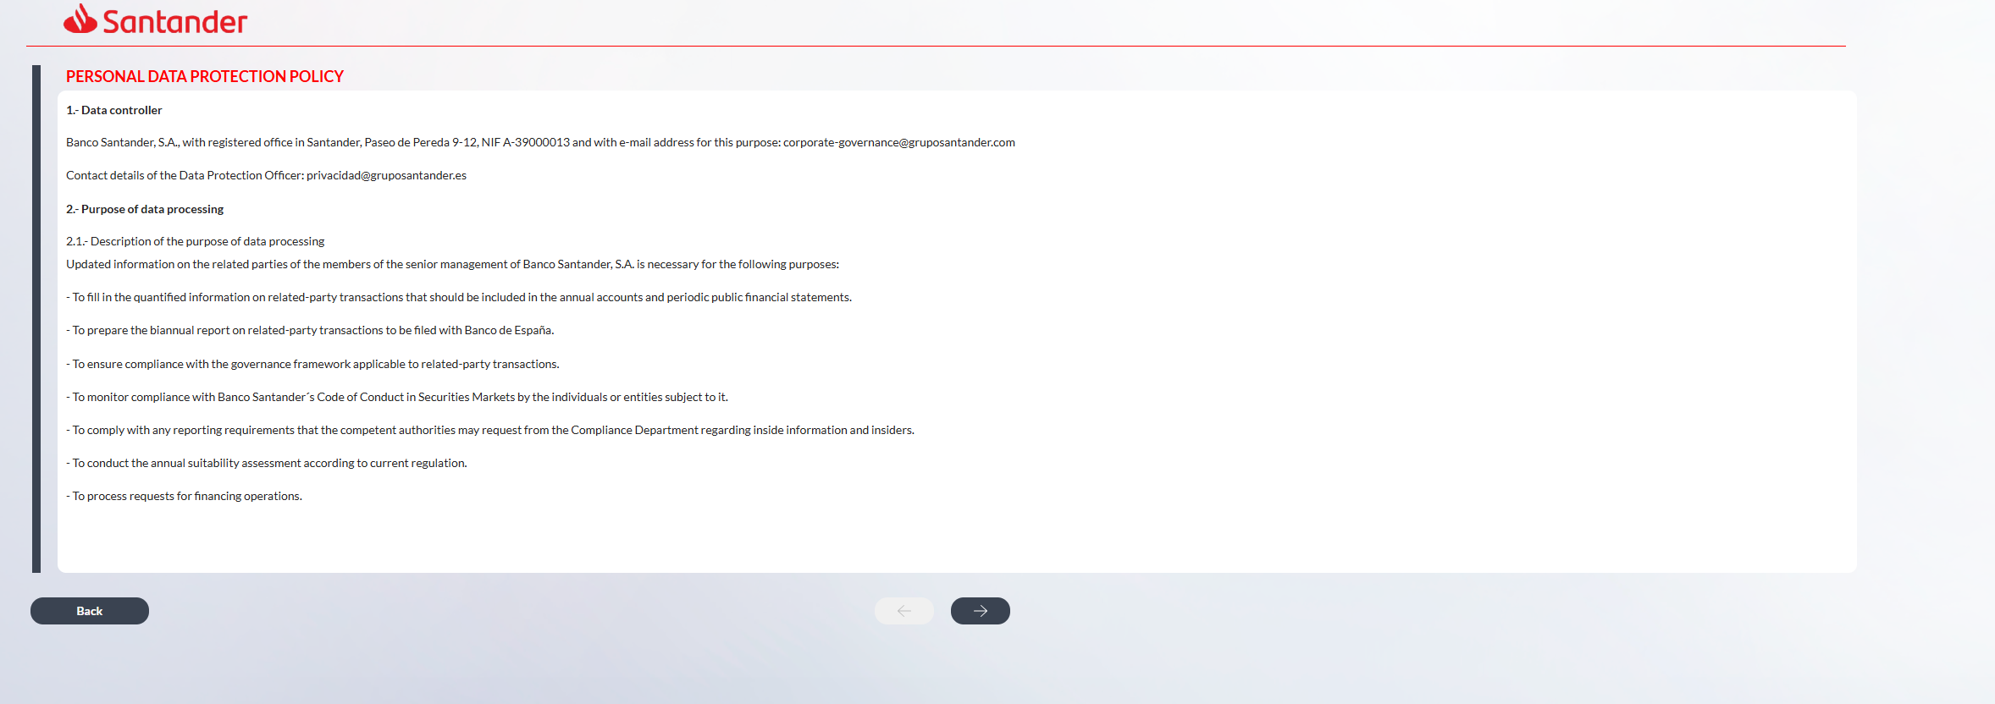
PERSONAL DATA PROTECTION POLICY
1.- Data controller
Banco Santander, S.A., with registered office at Paseo de Pereda 9-12, Santander, Spain, tax identification number (NIF) A-39000013, and e-mail address for these purposes: corporate-governance@gruposantander.com.
Contact details of the Data Protection Officer: privacidad@gruposantander.es.
2.- Purpose of data processing
2.1.- Description of the purpose of data processing
Updated information on the related parties of members of the senior management of Banco Santander, S.A. is required for the following purposes:
- to ensure compliance with the governance framework applicable to related-party transactions;
- to complete the quantified information on related-party transactions to be included in the annual financial statements and periodic public financial disclosures;
- to prepare the biannual report on related-party transactions to be submitted to Banco de España;
- to process requests for financing operations;
- to carry out the annual suitability assessment in accordance with applicable regulations;
- to monitor compliance with Banco Santander’s Code of Conduct in Securities Markets by the individuals or entities subject to it; and
- to comply with any reporting requirements that may be requested by the competent authorities from the Compliance function in relation to inside information and insiders.
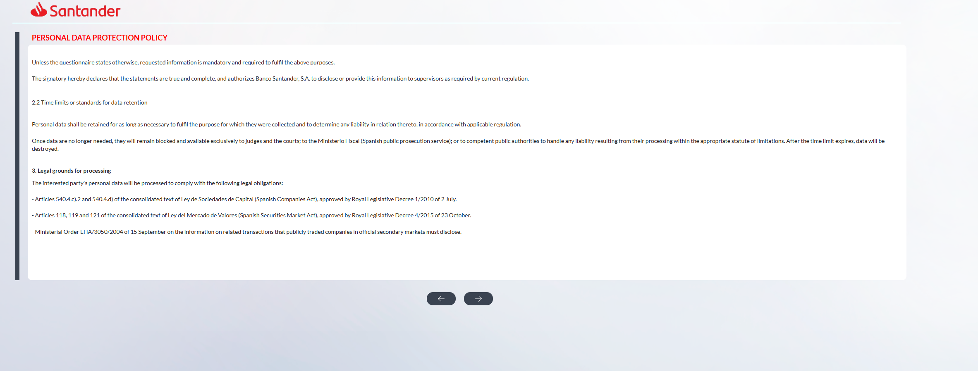
Unless otherwise indicated in the questionnaire, the requested information is mandatory and required to fulfil the purposes described above.
The signatory hereby declares that the information provided is true, accurate and complete, and authorizes Banco Santander, S.A. to disclose or provide this information to supervisors, as required under applicable regulations.
2.2 Data retention periods
Personal data shall be retained for as long as necessary to fulfil the purposes for which they were collected and to determine any potential liabilities arising therefrom, in accordance with applicable regulations.
Once the data are no longer necessary for these purposes, they will be blocked and made available only to judges and courts, the Ministerio Fiscal (Spanish public prosecutor’s office), or competent public authorities, for the purpose of addressing any potential liabilities arising from their processing within the applicable statutory limitation period. Upon expiry of such periods, the data will be deleted.
3. Legal grounds for processing Confirmar con Cumplimiento en el cuestionario de consejeros que las referencias normativas que les son aplicables no se han derogado y siguen vigentes
The personal data of the data subject will be processed in order to comply with the following legal obligations:
- Articles 540.4.c).2 and 540.4.d) of the consolidated text of the Ley de Sociedades de Capital (Spanish Companies Act), approved by Royal Legislative Decree 1/2010 of 2 July.
- Articles 118, 119 and 121 of the consolidated text of the Ley del Mercado de Valores (Spanish Securities Market Act), approved by Royal Legislative Decree 4/2015 of 23 October.
- Ministerial Order EHA/3050/2004, of 15 September, on the information on related transactions that publicly traded companies in official secondary markets must disclose.
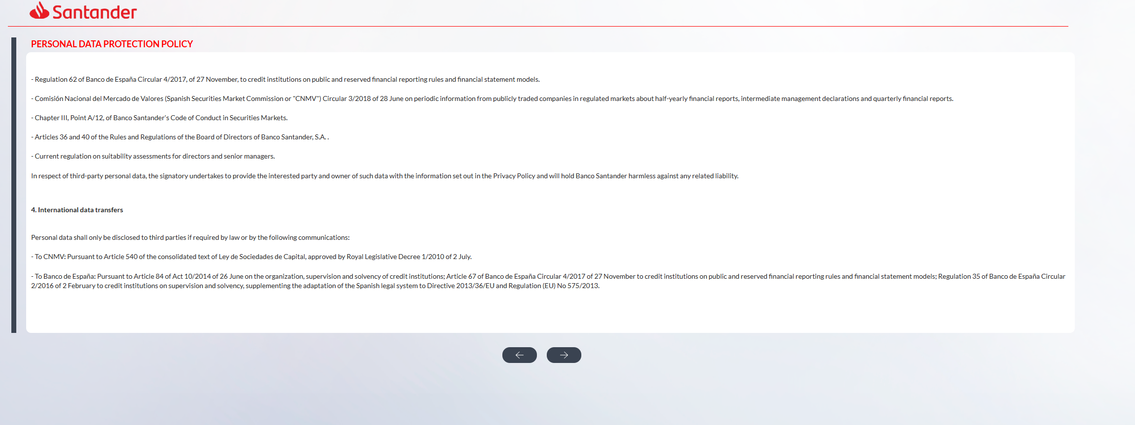
- Regulation 62 of Banco de España Circular 4/2017, of 27 November, to credit institutions on public and reserved financial reporting rules and financial statement models.
- Comisión Nacional del Mercado de Valores (Spanish Securities Market Commission or "CNMV") Circular 3/2018 of 28 June on periodic information from publicly traded companies in regulated markets about half-yearly financial reports, intermediate management declarations and quarterly financial reports.
- Chapter III, Point A/12, of Banco Santander's Code of Conduct in Securities Markets.
- Articles 36 and 40 of the Rules and Regulations of the Board of Directors of Banco Santander, S.A.
- Applicable regulations governing suitability assessments for directors and senior managers.
With respect to third-party personal data, the signatory undertakes to provide the interested party and owner of such data with the information set out in the Privacy Policy and will hold Banco Santander harmless against any liability arising in this regard.
4. International data transfers Confirmar con Cumplimiento en el cuestionario de consejeros que las referencias normativas que les son aplicables no se han derogado y siguen vigentes
Personal data will only be disclosed to third parties when required by law, including in the following cases:
- To CNMV: Pursuant to Article 540 of the consolidated text of Ley de Sociedades de Capital, approved by Royal Legislative Decree 1/2010 of 2 July.
- To Banco de España: Pursuant to Article 84 of Act 10/2014 of 26 June on the organization, supervision and solvency of credit institutions; Article 67 of Banco de España Circular 4/2017 of 27 November to credit institutions on public and reserved financial reporting rules and financial statement models; Regulation 35 of Banco de España Circular 2/2016 of 2 February to credit institutions on supervision and solvency, supplementing the adaptation of the Spanish legal system to Directive 2013/36/EU and Regulation (EU) No 575/2013.
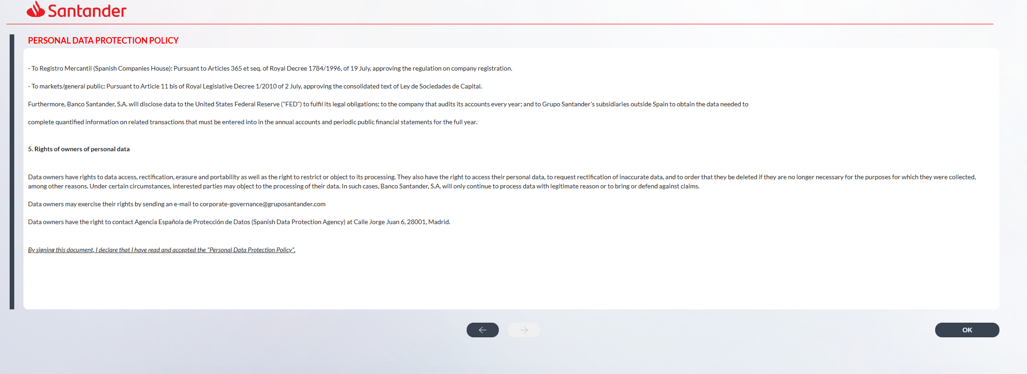
- To Registro Mercantil (Spanish Companies House): Pursuant to Articles 365 et seq. of Royal Decree 1784/1996, of 19 July, approving the regulation on company registration.
- To markets/general public: Pursuant to Article 11 bis of Royal Legislative Decree 1/2010 of 2 July, approving the consolidated text of Ley de Sociedades de Capital.
Furthermore, Banco Santander, S.A. will disclose personal data to the United States Federal Reserve ("FED") in order to fulfil its legal obligations; to the company that audits its financial statements each year; and to Grupo Santander's subsidiaries outside Spain, in order to obtain the information necessary to complete quantified information on related transactions that must be entered into in the annual financial statements and periodic public financial statements.
5. Rights of owners of personal data
Data owners have the right to access, rectify and erase their personal data, as well as the right to data portability and to request the restriction of, or to object to, its processing.
In particular, they have the right to request the rectification of inaccurate data or to the erasure of data where, among other reasons, it is no longer necessary for the purposes for which it was collected.
Under certain circumstances, interested parties may object to the processing of their data. In such cases, Banco Santander, S.A. will cease processing the data unless there are legitimate grounds for doing so of for the establishment, exercise or defence of legal claims.
Data owners may exercise their rights by sending an e-mail to corporate-governance@gruposantander.com.
Data owners also have the right to file a complaint with the Agencia Española de Protección de Datos (Spanish Data Protection Agency) located at Calle Jorge Juan 6, 28001 Madrid.
By signing this document, I declare that I have read and accepted the "Personal Data Protection Policy".
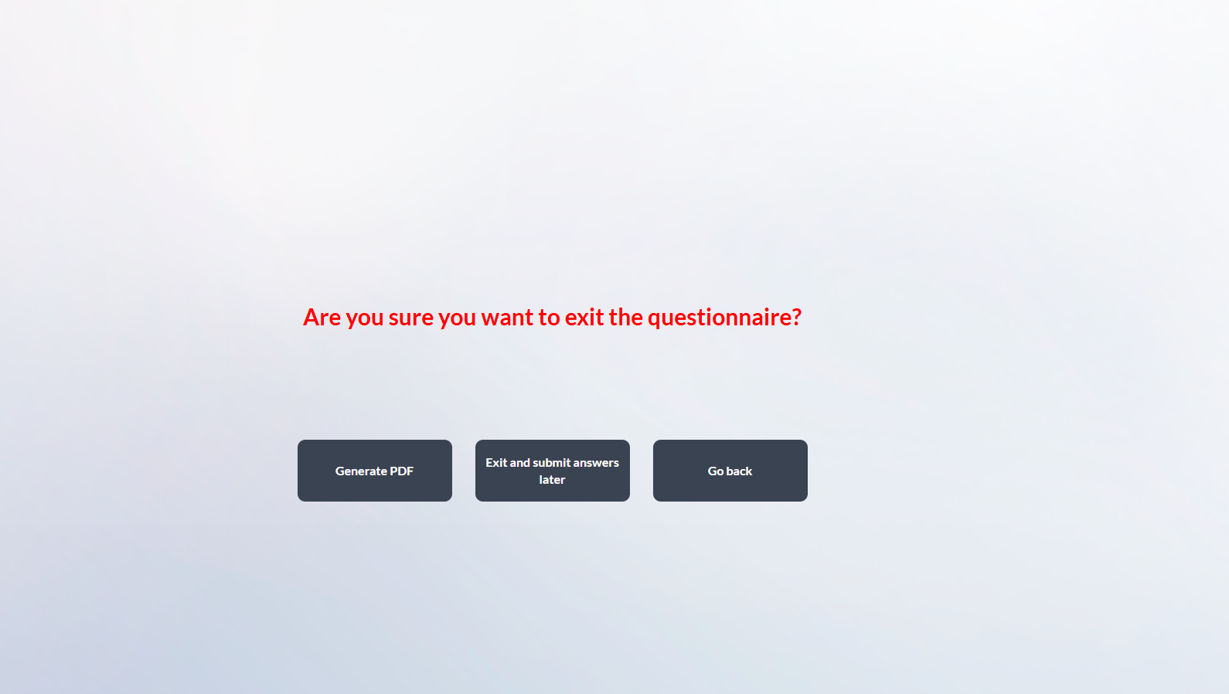

Textos de correos
- Inicio de campaña
Dear senior manager,
As part of our semi-annual process, Banco Santander is required to update information relating to senior managers' related-parties.
For this purpose, we kindly ask you to access the online application via the following link and review and update, where necessary, the information previously reported (please refer to the attached PDF). Once completed, the questionnaire must be signed and submitted through the application no later than XXday, XX June, 2026. Please find below a set of practical guidelines to assist you with this process.
Updating related-party information enables Banco Santander to comply with its corporate governance framework and applicable market abuse regulations, as well as to prevent and manage potential conflicts of interest. This information also supports the preparation of the related-party transactions note to the annual accounts, periodic public financial disclosures and the biannual report to Banco de España on outstanding financing transactions.
Should you have any questions, please do not hesitate to contact us at corporate-governance@gruposantander.com. For technical support, you may contact us by phone at +34 9128 97000 or by email at itsoportevip@gruposantander.com.
Thank you for your cooperation.
Legal Corporate Governance team
Questionnaire instructions:
- The information required for each section will be displayed in a window on the screen. It can also be accessed via the information icons located at the top left of the screen. Esto no lo veo en la herramienta, lo debieron eliminar cuando cambiaron la Plataforma, Habra que confirmarlo con Mozos.
- Please review all information, confirm that it is complete and up to date, or make changes where appropriate.
- To edit previously provided details, click the "Edit" button.
- To add new information, click the "Add" button.
- To confirm the information and proceed to the next screen, click the "Next" button.
- Once the questionnaire has been completed, click “Sign and send”. You will receive a confirmation e-mail including a PDF copy of the completed questionnaire.

- Recordatorio
Dear senior manager,
Please note that the deadline for completing the related parties questionnaire is XXday, XX June, 2026.
Please click on the following link to access the questionnaire and review and confirm or update the information.
Should you have any questions or require assistance, please do not hesitate to contact us at corporate-governance@gruposantander.com.
Thank you for your cooperation.

- Ultimátum
Dear senior manager,
Please note that the deadline for completing the related parties questionnaire is today.
Please click on the following link to access the questionnaire and review and confirm or update the information.
Should you have any questions or require assistance, please do not hesitate to contact us at corporate-governance@gruposantander.com.
Thank you for your cooperation.
Legal Corporate Governance team.

Por favor, cuando se firme el pdf, ya sea por el AD o por su asistente, debe enviarse el mismo correo electrónico, que es este a continuación:

- Confirmación de firma de formulario
Dear senior manager,
Please find attached a PDF document with the responses provided in the related parties questionnaire.
Thank you very much for your cooperation.
Legal Corporate Governance team

